Ryan, Paul (from Linked In)

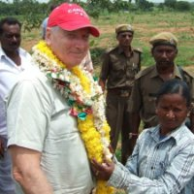

BSc Forestry ANU.1969-1972. Project Manager/Senior Project Manager Sandwell 1974 – 1983. Forestry Consultant 1983 – 1986 based in Vancouver, Canada. Forestry Specialist The World Bank 1986 – 1997 based in Washington DC, then Nairobi, Kenya. Forestry Development Consultant 1997 – . Retired 2013.

